Practical - 9
Practical Title: Secure User Registration with Database Insert, Duplicate Email Check, and Password Hashing Problem Definition: Implement secure user registration by inserting user details into MySQL using MySQLi. Validate input on frontend and backend, check duplicate email/username, hash passwords using password_hash(), and display appropriate messages.

Theory :

1. Is password_hash() used before storing passwords?
Yes. The password entered by the user is converted using password_hash() with
PASSWORD_DEFAULT before it is inserted into the database. The original password is never stored, and PHP adds a random salt to the hash automatically.

2. Is duplicate email/username checked?
Yes. Before the INSERT query, a SELECT query checks whether the email or username
already exists. If it exists, the message "Email or username already registered" is shown and no new record is inserted. A UNIQUE key on the email column in the table gives extra protection.

3. Are frontend and backend validations consistent?
Yes. The same rules are used on both sides: all fields are required, the email format must be valid, the password must be at least 8 characters, and the confirm password must match. The frontend (JavaScript) gives quick feedback, and the backend (PHP) validates again because frontend checks can be bypassed.

Evidence of Work (Screenshots):

Successful Registration:-



Password Mismatch error:
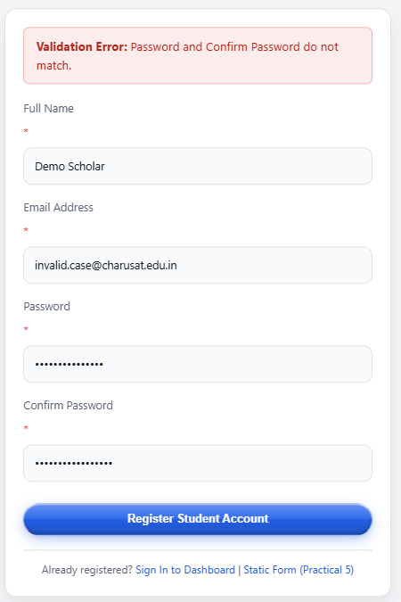

Duplicate email check:-
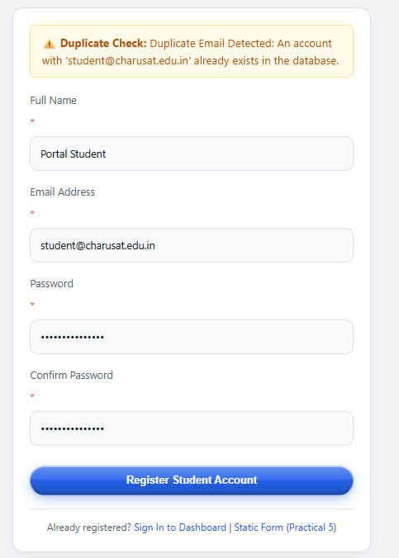

Repository Link :-
https://github.com/meet-3834/Student-Hub/tree/main/FINAL%20Submission

- Learning Outcomes:
I am able to implement secure user registration following basic web
security practices.

Faculty Remarks: (Keep this blank for faculty)

